CROSSOVER APPLICATION BOOKLET
June 2023

61 Broun Avenue, Morley WA 6062
Telephone: 9272 0622
Facsimile: 9272 0665
Postal address: PO Box 467, Morley WA 6943

Email: mail@bayswater.wa.gov.au
Website: bayswater.wa.gov.au

Contents
1. PROCEDURE 3
2. GENERAL INFORMATION 3
2.1 OBJECTIVE 3
2.2 STATUTORY REQUIREMENTS 3
3. CROSSOVER APPROVAL 4
4. WHAT IS A CROSSOVER? 4
5. WHO CAN CONSTRUCT THE CROSSOVER? 4
6. GEOMETRY 5
7. SIGHTLINES TO PATH USERS 5
8. REDUNDANT CROSSOVERS 5
9. ABUTTING NEIGHBOURING CROSSOVERS 5
10. CROSSOVER DENSITY 5
11. CROSSOVER WIDTH 5
12. PEDESTRIAN INTERFACE 6
13. SUBDIVISION CONDITION CLEARANCE 6
14. STREET TREES 6
15. PROTECTION AND SAFETY 6
16. PROTECTION OF INFRASTRUCTURE AND DISTANCE TO OBSTRUCTIONS 7
17. APPROVAL BY OTHER STATUTORY AUTHORITY 7
18. MAINTENANCE OF THE CROSSOVER 8
19. COUNCIL SUBSIDY 8
20. ELIGIBILITY FOR COUNCIL CROSSOVER SUBSIDY 8
21. RESPONSIBILITY OF THE APPLICANT AND/OR THE CONTRACTOR 9
22. EXCAVATION AND SUB-GRADE PREPARATION 9
23. WIDTH/ HEIGHT 10
24. MATERIALS 10
25. PROHIBITED LOCATIONS 10
26. IN-SITU CONCRETE 12
27. BRICK OR BLOCK PAVING 12
Appendix 1 – City of Bayswater Crossovers Policy 13
Appendix 2 – Crossover Construction Application Form 15
Appendix 3 – Crossover Site Plan Information 16
Appendix 4 – Crossover Subsidy Claim Form 17
Appendix 5 – Crossover Standards (Brick Paved) 18
Appendix 6 – Crossover Standards (Concrete Paved) 19
Appendix 7 – Path Standard (Path and Kerb Joint Detail) 20
Appendix 8 – Path Standard (Pram Ramp Detail) 21
Appendix 9 – Kerb Repair Requirements 22
Appendix 10 – Kerb Types 23
Appendix 11 – City of Bayswater Footpath Policy 24

PROCEDURE
Read the following statement and specifications.
- Complete Crossover Construction Application Form (Appendix 2) with Crossover Site Plan Information (Appendix 3) and submit to the City of Bayswater (the City).
- The City will respond within two-three weeks with approval or refusal of crossover. If the City is chosen to construct the crossover, a job cost estimate will be sent with the response.
- Construction of crossover may commence once approval is received. Payment of the amount quoted on the estimate is required up-front where the City is to construct the crossover. Construction may take up to four weeks but every effort will be made to complete the works within ten working days however delays may occur due to unforeseen circumstances.
- If you are entitled to the crossover subsidy (refer City of Bayswater Crossovers Policy – Appendix 1) and:
- The City constructs the crossover – the subsidy will be taken into account as part of the total job cost.
- A contractor constructs the crossover to the City’s specification – on completion of construction, the property owner is required to forward a copy of the receipt for the final cost of the crossover construction accompanied by the City’s Subsidy Claim Form (Appendix 4). The City will calculate the subsidy which will be issued following a satisfactory inspection of the crossover by the City’s representative.

GENERAL INFORMATION

2.1 OBJECTIVE
The objective of this document is to provide customers of the City of Bayswater with information regarding the City's requirements for vehicular crossovers and ensure a uniform approach to the construction of vehicle crossovers within the City of Bayswater area. The information within this booklet will ensure that crossovers:
- Are constructed to a uniform standard;
- Prevent stormwater from entering private land;
- Ensures safe entry and exit to properties;
- Provides a safe and even surface for pedestrians, cyclists, and disability access;
- Prevents negative impact on other infrastructure in the road reserve; and
- Maintains and/or improves the streetscape.

2.2 STATUTORY REQUIREMENTS
This specification is made pursuant to the Local Government Act 1995 (Schedule 9) and the Local Government (Uniform Local Provisions) Regulations 1996 (Regulations 12, 13, 14 & 15) references statutory and best-practice guidance documentation which includes the following:
- Austroads Guide to Road Design
- Australian Standard AS2890.1: Off-street parking (2004)
- State Planning Policy 3.1 - Residential Design Codes (R-Codes)
- WAPC Liveable Neighbourhoods

CROSSOVER APPROVAL
In accordance to Schedule 9.1, Clause 7 of the Local Government Act 1995 and Regulation 12, 13, and 15 of the Local Government (Uniform Local Provisions) Regulations 1996, an application to the Local Government must be made by the landowners to request approval to construct a crossover.

Please refer to Appendix 2 and 3 of this booklet for the Crossover Application Form.

The building licence is for construction inside the property boundary only and does not include the crossover. The position, width and construction of the crossover requires a separate application in accordance with the City of Bayswater Crossover Specification.

The City requires you to submit a Crossover Application Form prior to undertaking crossover works on the Council verge (section of land between your property boundary and the road edge). This enables the City to adequately assess your application to ensure that all requirements are being met. Please be aware that should you construct a crossover without the City’s approval, there is a chance you may be required to remove the crossover should it be deemed to not comply with the City's specifications.

Please note that the Crossover Application Form is located at Appendix 2 of this booklet. You will also need to attach a copy of your site plan (Appendix 3) to this application form and this must clearly indicate the following:

- Proposed location and dimensions of the crossover (length and width);
- Setback distance from the side boundary;
- Location and setback distance to any existing street trees; and
- Any existing infrastructure or services that may be affected by your proposed crossover (power poles, drainage pits/manholes, Telstra pits, bus shelters etc.).

WHAT IS A CROSSOVER?
A crossover is the section of driveway that extends from the road to the front boundary, across the Council verge. The property owner is responsible for the cost of construction and the ongoing maintenance of the crossover.

WHO CAN CONSTRUCT THE CROSSOVER?
The construction of your crossover, once approved by the City, can be carried out by:
- Your builder, or a private contractor engaged by you
If building a new dwelling, you may have already included the construction of the crossover in the contract between you and your builder. A crossover application is still required to be submitted for approval as the construction of the crossover does not fall within the approval of your building permit. You will need to ensure that your builder or contractor has a current copy of the City's Crossover specifications.

- The City of Bayswater
The City can provide you with a written, no-obligation quotation to construct a concrete crossover. If you would like a quotation, please check the box on the Crossover Application Form (Appendix 2) and a quotation will be sent for your consideration.

It is important to note that payment of the crossover is required to be made in full prior to the works being undertaken and all building works (including the internal driveway) must be completed before the crossover works can be scheduled.

GEOMETRY
Crossovers shall be aligned at right angles to the street alignment, wherever possible and must not be positioned outside the alignment of the internal driveway leading directly perpendicular to the garage/carport opening. Where existing infrastructure prevents this alignment, a modified shaped crossover may be considered at the City’s discretion on a case by case basis.

SIGHTLINES TO PATH USERS
Crossovers are to be positioned such that sight lines between path users and vehicles are unobstructed by permanent fixtures (fences, trees, etc). The crossover must not be constructed within the truncation of the property.

REDUNDANT CROSSOVERS
Crossovers that are no longer required or no longer connect with an internal driveway are deemed redundant. Under the City's Local Laws for ‘Activities on Thoroughfares and Trading Thoroughfares and Public Places’, redundant crossovers must be removed and the verge and kerb reinstated to the City's specifications at the cost of the Applicant.

ABUTTING NEIGHBOURING CROSSOVERS
Where the crossover abuts the neighbouring crossover, it is preferable for the gap between the two to be in-filled with brick paving or concrete (maximum width of 1.5m).

CROSSOVER DENSITY
The principle for designing crossovers in Western Australia is to design for the least number of crossovers in a given area, where possible. This improves the safety of path users and lowers costs associated with constructing and maintaining crossovers. Minimising the number of crossovers also reduces the level of conflict and friction along busier roadways, and creates additional space for street trees, pedestrian crossing, and on-street parking.

All residential lots are entitled to access irrespective of the constraints of location and sightlines (AS2890.1: Clause 3.2.3a).

Standard specifications (Appendices 5 and 6) allow for one crossover between 3.0m and 6.0m wide. Requests for a second crossover, widening of an existing crossover, crossovers exceeding 6.0m wide or other variations, will be considered upon submission of a written request including a site plan showing the position and width of all existing and proposed crossovers. These requests will be assessed on a case by case basis.

CROSSOVER WIDTH
Sufficient width and an adequate splay or 'wing' configuration must be provided for the safe turning movement of vehicles both from and onto the carriageway, in accordance with the City’s specifications (Appendices 5 and 6).

In regards to battle-axe developments: for a single battle-axe lot, the minimum driveway is 3.0m whereas for adjoining battle-axe lots, the combined driveway width shall be a maximum of 6.0m.

Where a property has a double carport/garage/hardstand but requires a modified shaped crossover to avoid existing infrastructure, the absolute minimum width for the crossover is 3.4m to allow adequate vehicle manoeuvrability.

PEDESTRIAN INTERFACE
Crossovers are defined to be 'Road-Related Areas' under the Road Traffic Code 2000. Pedestrians and cyclists in these areas have priority over vehicles. This specification is made pursuant to Regulations 12,13,14 & 15 of the Local Government (Uniform Local Provisions) Regulations 1996.
In addition, the City’s Footpath Policy (Appendix 11) takes priority over the crossover and must remain in plain grey concrete in accordance to the City’s specifications (Appendices 7 and 8). If any of the footpath panels in-line with the crossover are damaged or not of trafficable thickness (minimum 100mm) the footpath panels must be upgraded to the City’s footpath specifications, with all associated costs borne by the applicant/property owner.

SUBDIVISION CONDITION CLEARANCE
The construction of a crossover can be prepaid to clear subdivision conditions. Please note that should you sell the land associated with the crossover pre-payment, the pre-payment will go with the sale of the land (be transferred to the new owner who can then use these funds for the City to construct the crossover once their dwelling is completed, or if constructed privately to the City’s specifications, will be refunded to the new owner).

STREET TREES
Street trees on Council verges will not be removed to accommodate crossovers without due consideration of alternatives. A minimum clearance of 2m from the base of the existing street tree and the location of the proposed crossover must be provided. Due care must be taken to protect the street tree(s) from damage during the construction of the crossover. This includes protecting the root structure of the tree and not pruning the canopy without specific, written authorisation from the City of Bayswater.

PROTECTION AND SAFETY
Vehicle crossovers shall be constructed under the supervision of, and to the satisfaction of, the City’s nominated officer in accordance with the City’s Crossovers Policy, Drawing 16/18 and this specification. Protection of the works and the public both during and after construction shall be the responsibility of the applicant and his/her contractor, who shall supply and install all necessary warning signs, barriers, warning lights (during the hours of darkness), temporary bridges or any other action necessary or as may be directed by the City’s officer. Failure to do so shall constitute an offence under Section 377 of the Local Government Act 1995.
All works are to be carried out in accordance with the Occupational Safety and Health Act 1984 and its regulations as amended. Any damage which may occur to the City’s infrastructure assets or to private property during the course of the works, or arising from them, shall be the sole responsibility of the applicant and his/her contractor, whom shall be held responsible for the replacement or repair of such property, and for any other claim or liability arising out of the works.
A person wishing to construct a crossover should contact the relevant service authorities including, but not necessarily limited to, Dial before you Dig, the Water Corporation, Western Power, ATCO Gas, and Telstra. The City shall not be responsible for any damage or interference with the crossover caused by service authorities.
All crossover works require a Traffic Management Plan (TMP) and a City of Bayswater TMP approval prior to any works being completed. The TMP must written by an authorised Main Roads WA (MRWA) accredited traffic management company and lodged with the City at least 10 working days prior. Fees and charges apply - refer to the website for more details.

PROTECTION OF INFRASTRUCTURE AND DISTANCE TO OBSTRUCTIONS
Crossovers shall have the following minimum clearances:
- Side boundary 0.5m
- Street tree 2.0m
- Drainage side entry pits 1.0m
- Western Power Poles 0.5m
- Public Utility infrastructure - as per public utility requirement.
Minimum distance from intersection point at corner sites - 6.0m. (Refer drawing 40/07 pg. 11).
The position of all utilities, public transport, and storm water objects must be considered prior to the placement and construction of the crossover.

These objects should be avoided and can only be moved or modified to accommodate vehicle traffic at the owner's cost, following approval from the City and relevant government authority. This includes power poles, street lights, bus shelters, storm water grates and/or side entry pits, Telstra and Water Corporation pits, NBN transformers etc.

A person wishing to construct a crossover where said infrastructure is currently located, must contact the relevant service authorities including, but not necessarily limited to, Dial before you Dig, the Water Corporation, Western Power, ATCO Gas and Telstra to ensure their infrastructure is trafficable or to arrange suitable changes prior to commencing any works within the road reserve. The City is not responsible for contacting any service provider should you engage the City to undertake the construction of the crossover, and any changes required to existing infrastructure must be completed prior to the City coming to site to commence crossover construction.

It is important to note that some streets within the City of Bayswater have high pressure gas lines located within the road reserve (verge). It is imperative that properties with this infrastructure located within the verge contact ATCO GAS on 13 13 56 prior to undertaking any works within the road reserve.

There may be times when service providers need to undertake works within the road reserve, which may affect your crossover. Please note that the City shall not be responsible for any damage or interference with the crossover caused by service authorities.

APPROVAL BY OTHER STATUTORY AUTHORITY
Vehicle crossovers adjacent to the following major roads are subject to the approval of MRWA, in conjunction with the City of Bayswater. You will be required to submit a copy of the approval for construction of a crossover from the Commissioner of Main Roads WA with your Crossover Application.

- Guildford Road, (all); and
- Morley Drive (between Wellington Road and Tonkin Hwy)

Access and egress from properties located on these roads must be made in forward gear. Please contact MRWA directly on 13 81 38.

Vehicle crossovers adjacent to the following Regional Roads and Local Distributor Roads are subject to approval by the Western Australian Planning Commission (WAPC):

Beechboro Road North | Beechboro Road South | Benara Road
Broun Avenue | Camboon Road | Collier Road
Coode Street | Crimea Street | Drake Street
Emberson Road | Embleton Avenue | Garratt Road
Grand Promenade | Grey Street | King William Street
McGilvray Avenue | Morley Drive East | Peninsula Road
Railway Parade | Walter Road West | Wellington Road
Widgee Road | Whatley Crescent
It is important to note that access and egress from properties located on these roads, as well as from carparks and Right of Ways (ROWs) must be made in forward gear.

Please contact the WAPC directly on (08) 6551 9000.

MAINTENANCE OF THE CROSSOVER
In accordance with the Local Government Act 1995, maintenance of the crossover is the sole responsibility of the adjacent property owner, to ensure it remains in a safe and trafficable condition once constructed.

Property owners are strongly encouraged to upgrade old bitumen crossovers to comply with the City’s current crossover specifications (concrete or brick paving). This is promoted through the conditions of development approval, and directly through the City. The property owner may be entitled to a crossover subsidy (Appendices 1 and 4) as per below.

COUNCIL SUBSIDY
In accordance with the City’s Crossovers Policy, and under Regulation 15 of the Local Government (Uniform Local Provisions) Regulations 1996, it states that where a crossing (hereafter called a crossover) is constructed:
- To the first crossover constructed to the private land; and
- A standard crossover or a type that is superior to a standard crossing,

the City is obliged to bear 50% of the cost, as estimated by the Local Government, of a standard grey concrete crossover.

The City of Bayswater defines a standard crossover as:
- A minimum of 3m wide at the property boundary line;
- Constructed in concrete to the City's specifications;

ELIGIBILITY FOR COUNCIL CROSSOVER SUBSIDY
To be eligible to claim the Crossover Subsidy you must submit a Crossover Subsidy Application Form (Appendix 4) and meet the following eligibility criteria:
- The crossover is the first crossover to the property
- The crossover is an upgrade from a bitumen crossover to a standard crossover (where a crossover subsidy has not been previously claimed for a standard brick paved or concrete crossover);
- The crossover is a standard crossover (Appendices 5 & 6) as defined above
- Crossover Subsidy Application (Appendix 4) is received within six (6) months of the crossover being constructed
- Documentary evidence (contractor's invoice/receipt) is attached to the Crossover Subsidy Application Form which clearly states the applicant's address
- All conditions of the Crossover Approval have been met (including but not limited to set levels and a box inspection carried out by a City officer).

RESPONSIBILITY OF THE APPLICANT AND/OR THE CONTRACTOR
The Applicant and/or their contractor is responsible for the following items:
- The lodgement of the Crossover Application Form (Appendix 2) prior to any works being carried out and the arrangement of all required inspections as stipulated in the approval conditions.
- Where required, the cutting of the existing semi-mountable or barrier kerbing (Appendices 7 & 9) with a concrete saw and removing existing kerbing without damage to remaining kerbing and road pavement.
- The removal and disposal of all surplus materials from the site of the works and leaving the site in a clean and tidy condition at all times.
- The reinstatement of kerbing, concrete, brick paving or bituminous road surfaces damaged during the course of the work during the construction of the crossover
- The reinstatement of the verge area adjoining the crossover.
- Crossovers that are no longer required or no longer connect with an internal driveway are deemed redundant and must be removed and the verge and kerb reinstated at the cost of the applicant.
- Application to the relevant public utility authorities for approval to alter any utility service that is in conflict with the proposed crossover. Any costs incurred in the alteration of any service and subsequent reinstatement of the verge shall be borne by the Applicant.
- The cost of any traffic management that may be required to ensure the safety of road users, contractors, and pedestrians during the construction of the crossover. Only qualified traffic management personnel shall be used and all traffic management shall be in accordance with Main Roads Western Australia's code of Practice ‘Traffic Management for Roadworks’ and Australian Standard AS1742.3-2002. A copy of the traffic management plan must be lodged with the City for approval prior to the works being carried out. Refer to the City’s website for current fees and charges.
- It is recommended that you contact Dial Before You Dig on 11 00 or via www.1100.com.au prior to your works to determine the location of services within the road reserve before any excavation works.
- The property owner is required to maintain the crossover to a safe and trafficable condition once constructed.

EXCAVATION AND SUB-GRADE PREPARATION
The surface for the crossover shall be cut to the lines and grades shown on the standard drawings. If the site has an existing footpath, this is to be used to set the crossover levels; otherwise, the City will set the level at the property boundary upon request from the contractor. A minimum of 48 hours' notice is required prior to setting out of levels (telephone 9270 4123 to arrange). As footpaths are normally only 75mm - 100mm thick, they are to be removed and the crossover built through the path to the property boundary.

All grass, roots, and other vegetation matter, clay, or any other deleterious matter shall be removed for a depth of not less than 300mm below the finished sub-grade level.

The sub-grade shall be compacted by watering to a depth of at least 450mm and mechanical compaction (such as a small plate compactor) to give a uniform compaction over the whole of the crossing place.

If the verge level is altered by the construction of the crossover then the verge each side of the crossover is to be shaped so that the maximum slope is 1 in 10.

WIDTH/ HEIGHT
The maximum width of a crossover at the property boundary (fence line) is 6.0m, with a minimum clearance from the side boundary of 0.5m. Generally, the width of the crossover will not exceed 50% of the length of the total boundary facing the street (battle-axe access and narrow cul-de-sac frontages are exempt).
Crossovers greater than 6.0m will require substantiative evidence of the necessity for a greater width which the City reserves the right to refuse. The crossover's width and height are to be in accordance with the specifications as shown on accompanying drawings ‘Crossover Standard (Brick Paved) Drawing 16/18’ or ‘Crossover Standards (Concrete) Drawing 16/18' ' (Appendices 5 and 6).

MATERIALS
Crossovers may be constructed in one of the following materials:
- In-situ 25MPa concrete (broom finish and exposed aggregate only (wood float finish is not permitted).
- Clay brick paving (60mm thickness)
- Concrete block paving (60mm thickness)

PROHIBITED LOCATIONS
Australian Standards (AS2890.1: Figure 3.1) sets out exclusion zones for access driveways related to the proximity of adjacent intersections (see Drawing 40/07 on page 11).

Where the property is on a corner or at a road intersection, no new crossover will be constructed within 6.0m of the kerbing transition point, the side boundary alignment or the front boundary truncation peg whichever is furthest from the alignment of the adjacent side road unless the size and/or shape of the property prevents the preferred locality (see attached Drawing 40/07 on page 11 - Vehicle Crossover Location). This exclusion zone may be increased if necessary for signalised intersections to ensure that the driveway is not within the influence of traffic queues. This requirement does not apply to any access driveway serving a property which would otherwise be denied access due to the physical impossibility of meeting the requirement. Additional restrictions are placed on non-domestic driveways and should be discussed with Local Government.

Vehicle Crossing Location
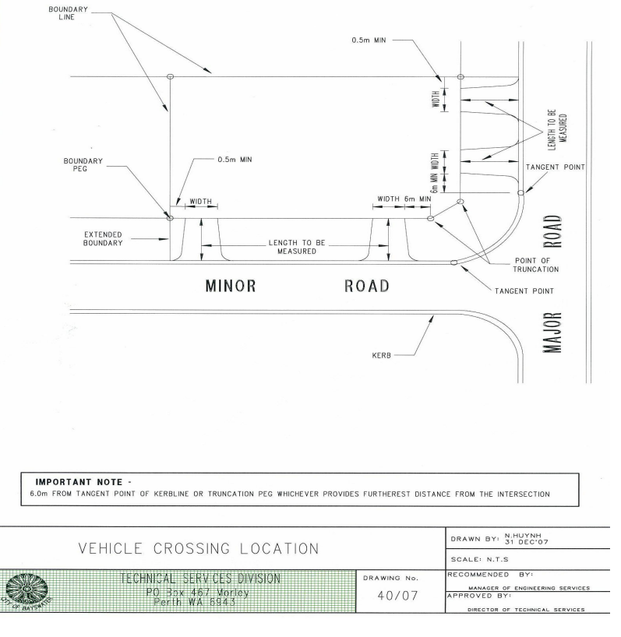

IN-SITU CONCRETE
An in-situ concrete crossover shall consist of a slab of 100mm thick concrete placing on a compacted sub-grade in accordance with the City's specifications.

Concrete strength shall be 25MPa in accordance with Australian Standard 3600. Maximum aggregate size shall be 20mm and slump shall not exceed 80mm.

Expansion joints shall be placed at the boundary and between the slab and the kerb (refer drawings). The expansion joint shall be the full depth of the slab filled with approved rubber or plastic foam and sealed with butyl mastic.

The surface of the slab shall be screeded to correct levels. Broom finished to provide a dense uniform non-slip surface. The surface shall be free of depressions, joint marks, honeycombed sections, or dusty sections which may cause excessive wear.

On steep crossovers, the City’s officer may direct that the surface be grooved in order to provide sufficient non-slip properties.

BRICK OR BLOCK PAVING
Paving bricks shall be clay brick or concrete pavers from an approved manufacturer.

Pavers shall be laid on a prepared sub-base comprising of a compacted sub-grade in accordance with specifications overlaid with a bedding layer of clean coarse sand, in accordance with the manufacturer’s recommendations.

Rigid block or concrete edging is to be provided at the perimeter of all block paved crossovers to prevent lateral movement of the header course.

Restraints shall be robust enough to withstand vehicle impact and prevent the lateral movement of the paving blocks. Edge restraints shall be installed to the same level as the crossover.

Brick or block paved crossovers shall be constructed with a concrete apron between the road and the crossover as per Appendix 5.

Pavers shall be laid in a herringbone patter or stretcher bond pattern at 45° or 90° for square pavers.

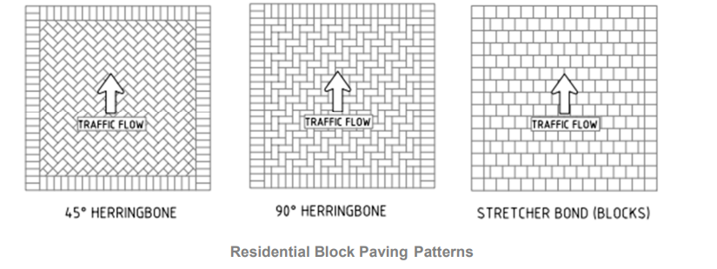

Appendix 1 – City of Bayswater Crossovers Policy
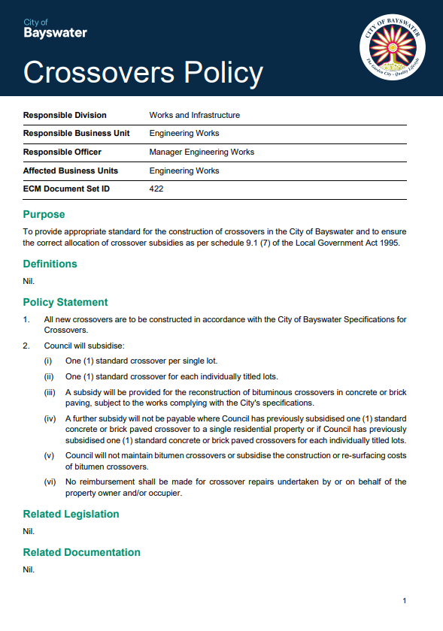

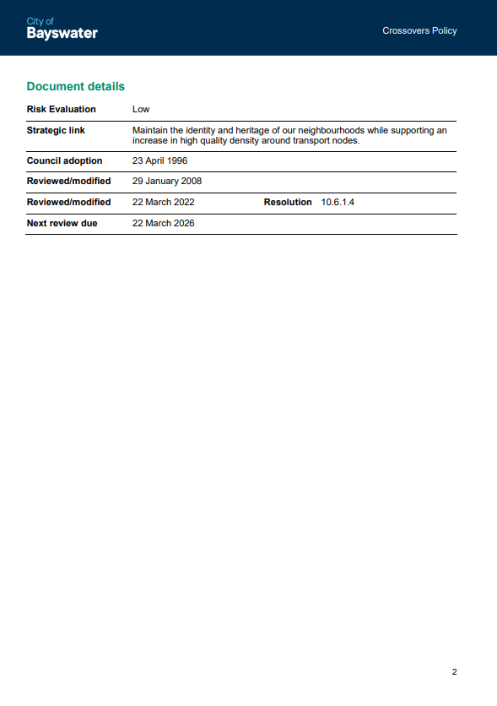

Appendix 2 – Crossover Construction Application Form

Applicant/s Name:
Mailing Address:
Suburb: |  | Postcode
Email:
Telephone: (daytime contact)
Address of proposed crossover:

I would like the City of Bayswater to provide a quotation for the installation of a concrete crossover:
☐ (please tick if relevant)

This application is for: (please tick)
☐ A new crossover ☐ For subdivision
☐ Upgrade of an existing crossover ☐ Widening of an existing crossover

Type of construction:
☐ Concrete ☐ Brick / block paving
NOTE: You must attach a copy of your approved site plan, which shows the following details:
- Location and dimensions of proposed crossover
- Name of street frontage
- Distance from the nearest site boundary
- Location of all existing infrastructure (e.g. utility, pit, street tree, drainage, bus shelter etc.).

ACCEPTANCE
I hereby accept the conditions as set out in the City of Bayswater Crossovers Policy and confirm that the application is in accordance with all relevant planning conditions relating to the property.

Applicant/s signature: ______________________________ Date: Click or tap to enter a date.

Please return completed application to: mail@bayswater.wa.gov.au, alternatively mail to City of Bayswater, PO Box 467, Morley WA 6943

Appendix 3 – Crossover Site Plan Information

LOCATION PLAN

If this application is to upgrade OR widen an existing crossover in the same location.

Attach a sketch or site plan of the property showing:

- The internal parking area and crossover location and dimensions
- Name of Street frontage
- Distance from nearest side boundary
- Location of verge assets (bus shelter, utility pits, drainage grates etc)
- Reversing bays (if applicable)
- Any existing street tree showing the distance between the tree and the crossover
- Clearly mark if you are:
- upgrading the existing crossover
- widening the existing crossover

If this application is for subdivision clearance, a new dwelling, or seeking approval for an additional crossover/change of location:

- Please attach a copy of your Site Plan (scale 1:200) showing:
- Driveway and Crossover location and dimensions
- Driveway and hardstand materials
- Name of Street frontage
- Distance from nearest side boundary
- Contours and/or spot levels
- All setback distances
- Location of retaining walls (if applicable)

Does this application have Development Approval? ☐ Yes ☐ No

Development Application number: Click or tap here to enter text.

Appendix 4 – Crossover Subsidy Claim Form
Attention: Verge Bond/Crossover Officer

Date: Click or tap to enter a date.

The address of the crossover to be inspected is: Click or tap here to enter text.
Crossover was constructed by: Click or tap here to enter text. Date: Click or tap to enter a date.

Note: A copy of the contractor’s receipt must be attached to this claim form.

Levels pegged by the City? ☐ Yes ☐ No Date: Click or tap to enter a date.

Box inspection/Form work inspected by City officer? ☐ Yes ☐ No Date: Click or tap to enter a date.

Note: The crossover subsidy is only payable for the crossover constructed strictly in accordance with the City’s specifications, crossover policy and current fees and charges. This also includes inspections undertaken at the formwork/base stage and after completion.

OWNER’S DETAILS
Owner’s Name:
Email:
Postal Address:
Contact number: | H/W: |  | Mobile:

BANK DETAILS
Name of Financial Institution:
Branch: |  | Account Name:
BSB No. (6 digits) |  | Account Number:

CONDITIONS OF CONSENT
- I hereby declare that I am the owner of the abovementioned property and that this is the first subsidy claim made for the said property. I have attached a copy of the contractor’s receipt to this application. (Note: Subsidy can only be paid to the current owner, and must be made within six months of crossover construction).
- I understand that the crossover subsidy will be paid by Electronic Funds Transfer (EFT – payment made directly to the depositor’s bank account).
- The authorised representative is responsible for the accuracy of the particular above.
- The authorised representative is responsible for advising the City of Bayswater (COB) in writing of any changes to the particulars above. Upon receipt of such notification, COB will amend its records accordingly.
- COB will accept the authority of the Authorised Representatives as conclusive evidence of that person’s authority to sign this consent. COB is under no obligation to verify that authority or any of the details provided above but may do so it chooses.
- COB will use all reasonable measures to maintain the confidentiality of the information provided. The authorised representative acknowledges that details will be available to COB staff or other individuals carrying out their normal duties in processing invoices/accounts for payment on behalf of COB.
- While the preferred method of payment is EFT, the authorised representative acknowledges that payment may still be made by other if circumstances require.
- By signing this form, the authorised representative acknowledges his or her responsibilities under the conditions of this consent form.

Name: Click or tap here to enter text. Signature:__________________________ Date: Click or tap to enter a date.

Appendix 5 – Crossover Standards (Brick Paved)
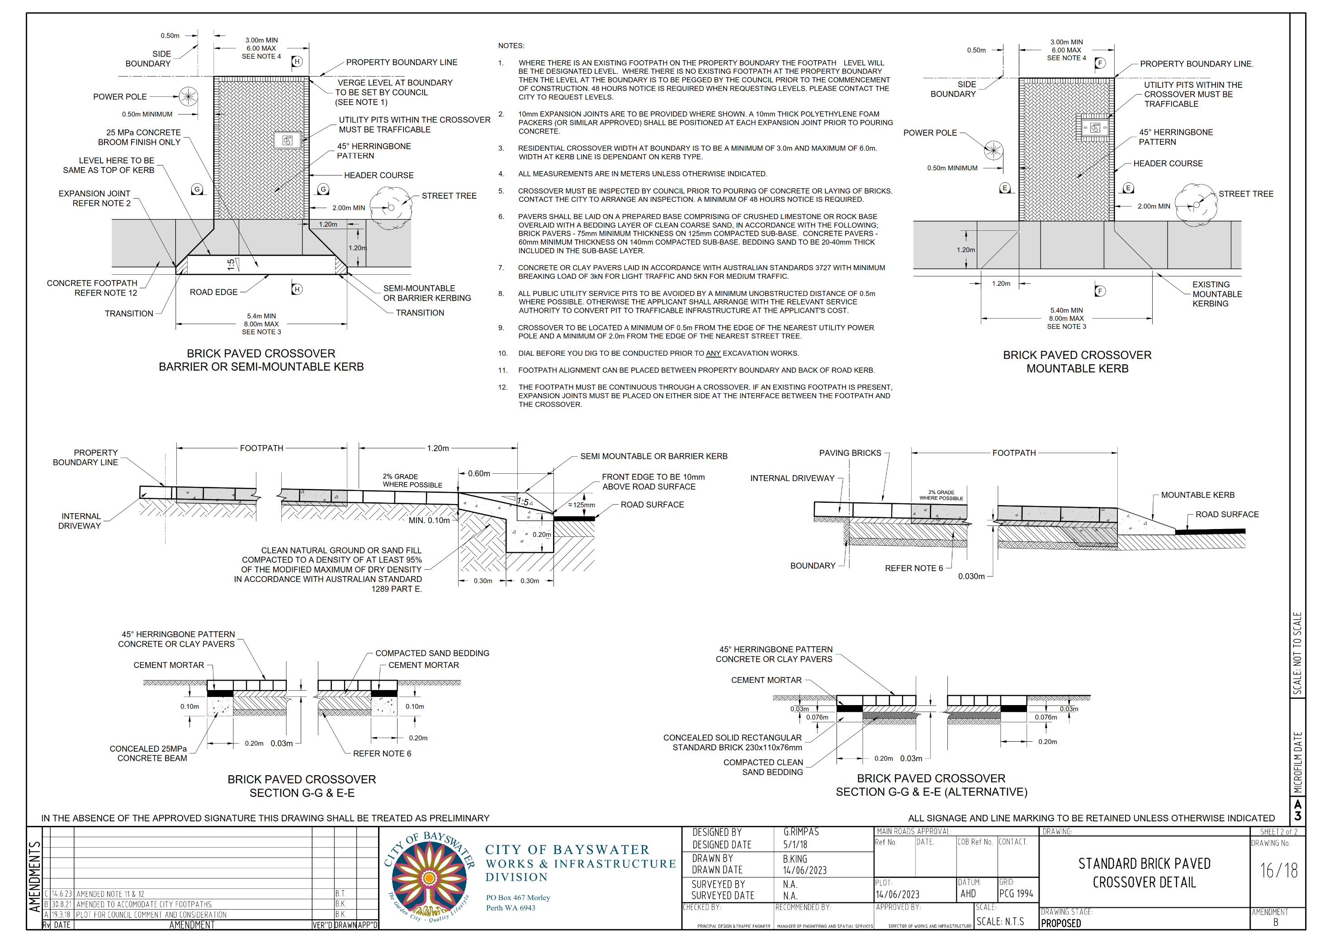

Appendix 6 – Crossover Standards (Concrete Paved)
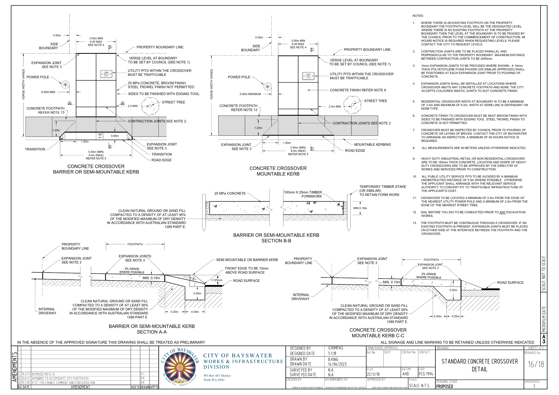

Appendix 7 – Path Standard (Path and Kerb Joint Detail)
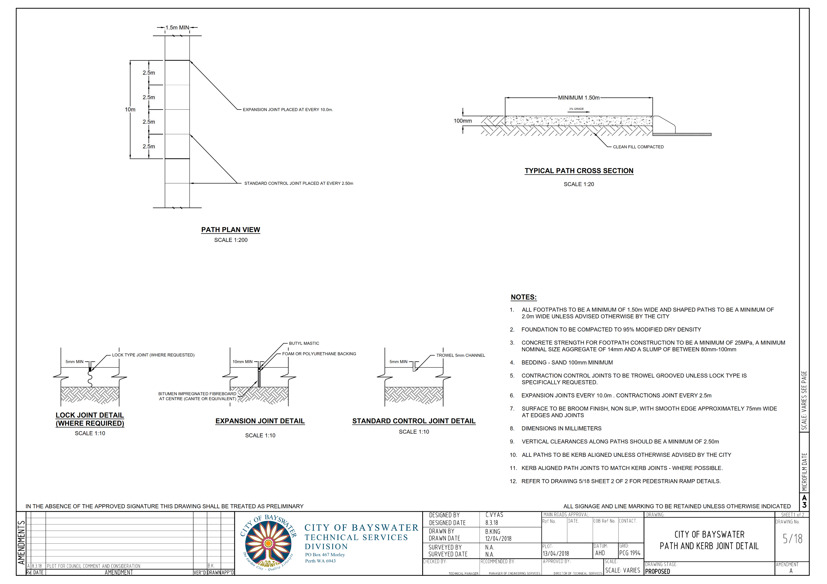

Appendix 8 – Path Standard (Pram Ramp Detail)
1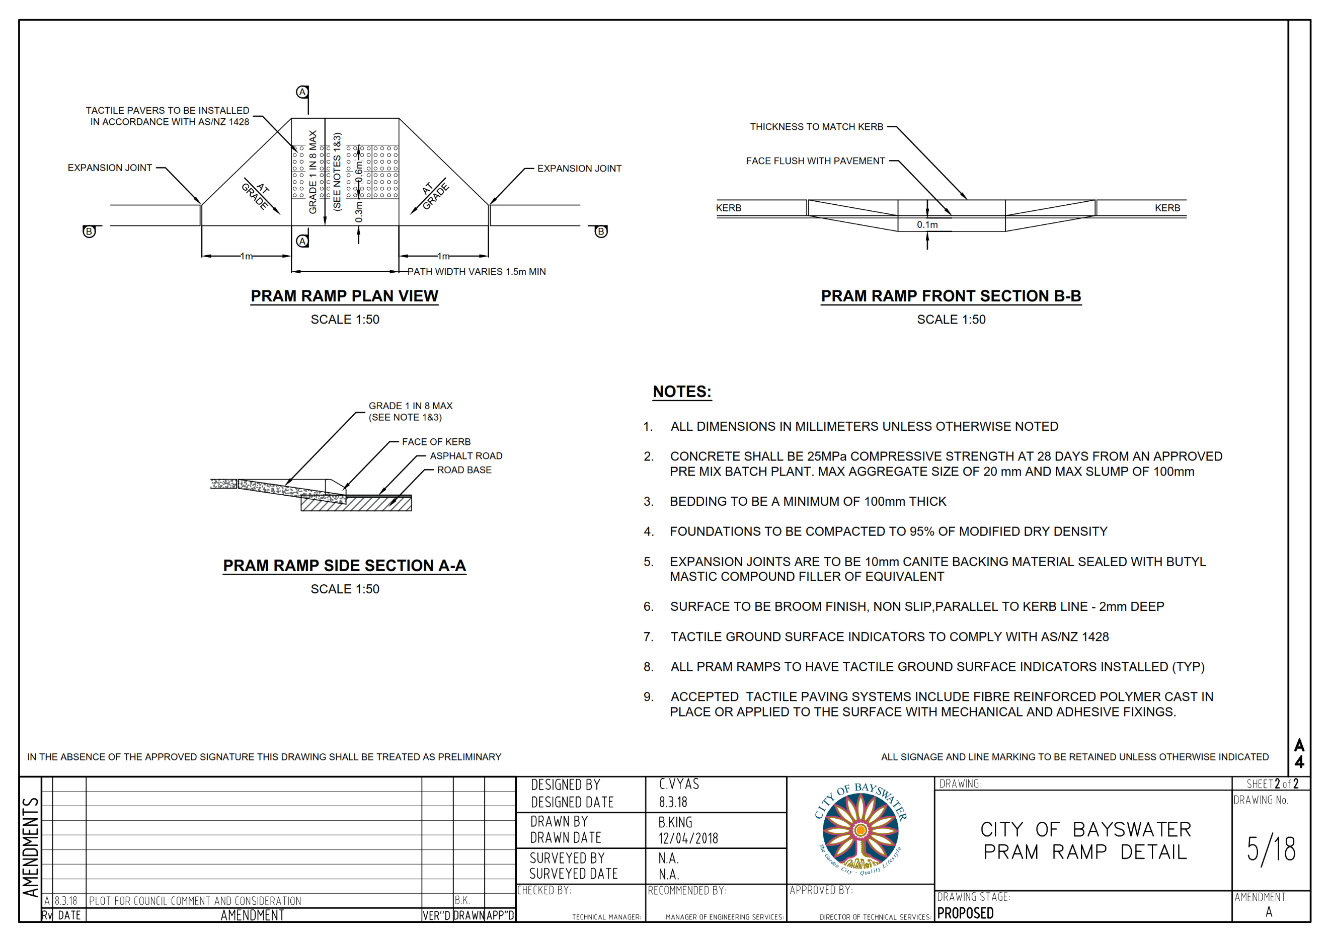

Appendix 9 – Kerb Repair Requirements
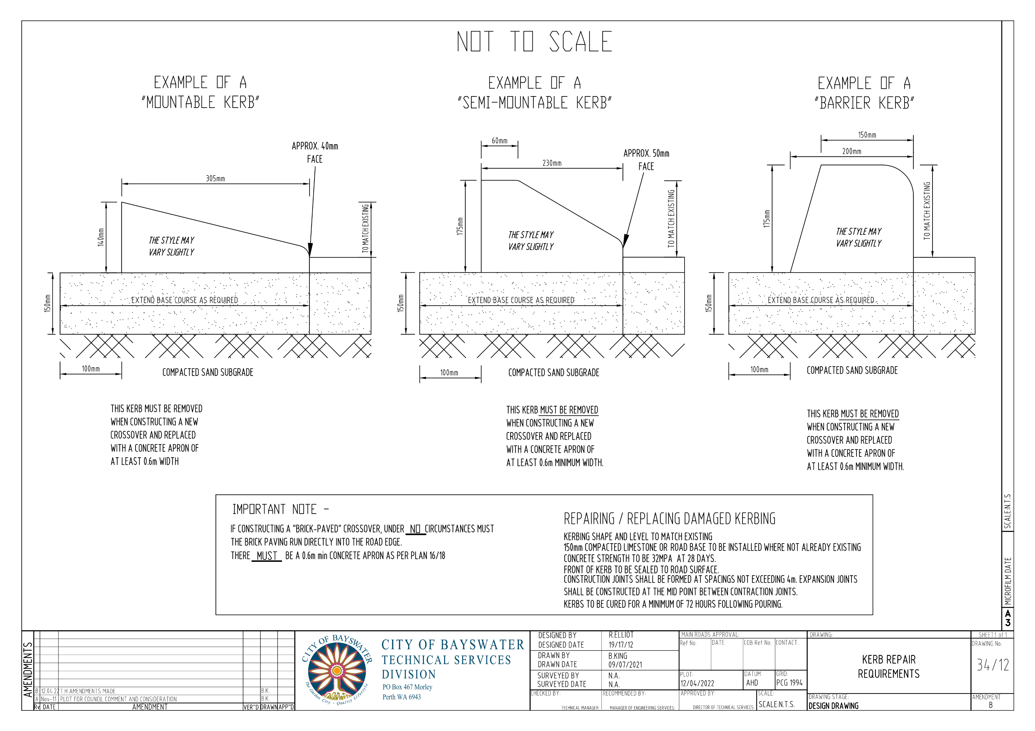

Appendix 10 – Kerb Types
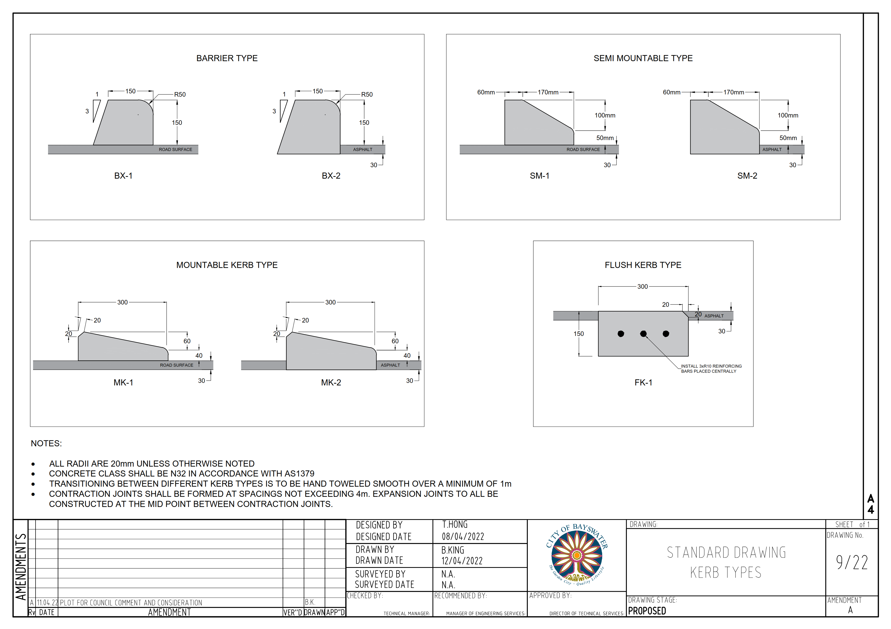

Appendix 11 – City of Bayswater Footpath Policy
