The City has developed Edible Pocket Garden Guidelines to empower and support its residents to practice sustainable living through growing edible plant species, making better use of public spaces and supporting more active and engaged communities.
Edible pocket gardens refer to areas of Council land within parks and reserves that have been approved to be used for growing edible produce for residents. To install edible pocket gardens please follow the simple approval process below.
Approval process
Residents are required to complete the approval process before the garden is built. Gardens built before the 24 January 2018 are not required to complete steps One to Three.
- Step One - Contact the City's Parks and Gardens team on 9270 4152 or mail@bayswater.wa.gov.au to discuss the initial edible pocket garden concept and location.
- Step Two - The City may approve the edible pocket garden, request the resident to provide a simple sketch of their proposal or ask to meet the resident on site to help provide advice on how they can meet the Edible Pocket Garden Guidelines.
- Step Three - The City will provide written approval for the resident to proceed or if the project location is not suitable the resident will receive an explanation.
- Step Four - City officers will inspect the garden following initial installation as well as undertake an annual inspection to ensure the garden meets the requirements of the guidelines. It should be noted that informal periodic inspections will also be undertaken during park maintenance activities.

Edible Pocket Garden Design Guidelines
- The edible pocket gardens should positively contribute to the reserve or community and not conflict with the existing use of the reserve by the community.
- The design should not require significant changes to parks landscaping regimes which could result in increased costs to the City.
- The design should consider the existing assets in the location and not impact above or below ground services.
- The design should consider the location of existing vegetation (trees, shrubs etc.) and ensure it does not have a negative impact on the health or future growth of the vegetation.
- The design should not include plants that may reasonably be considered to pose a hazard to people; such as plants that are poisonous, have large thorns or cause common allergic reactions.
- Undue hazards and sharp objects such as star pickets cannot be placed in the garden.
- Edible pocket gardens are not to be fenced and will be accessible to all members of the community.
- Applicants should consider avoiding the installation of plants that have high water consumption rates.
- Applicants should consider the list of suitable plants for edible pocket gardens on the City website.
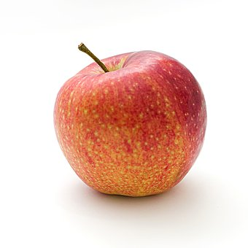

Responsibilities of Residents
- Contact utility providers or 'dial before you dig' to ensure that the edible pocket garden will not impact on existing infrastructure.
- Ensure that an approval by the City has been granted before works begin.
- Should the edible pocket garden be proposed to be directly adjacent to a private property, a letter of support must be sought from the property owner.
- Ensure that the edible pocket garden meets and continues to meet the Edible Pocket Garden Guidelines.
- Ensure that the site conditions of the reserve meet the choice of plants to be grown in the garden.
- Ensure that the garden is well maintained; including that produce is harvested regularly, managed for fruit fly (if relevant) and the site is weed and pest free. Chemical pesticides and herbicides are not permitted to be applied to gardens.
- Supply and purchase of resources required for the garden are at the residents’ expense.
- Residents are responsible for their own safety and wearing of adequate personal protective equipment.
- Ensure that the site is left in a safe condition for other park users at all times.
- Ensure that tools and materials are not to be left on site.

Things to consider
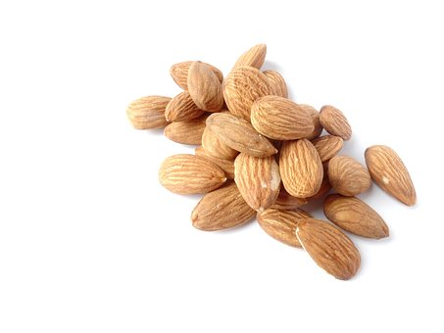
- This activity is considered to be a private or recreational pursuit and as such the City is not responsible for personal injury caused by a member of the public to themselves or a third party.
- Discuss your project with your neighbours and reserve users to identify any potential competing uses of the reserve, or if they would like to help build and maintain it.
- The community will have access to the garden and you will not be the owner of the produce. The City will not be involved in regulating the distribution of produce from edible pocket gardens in any way.

If a garden is considered to pose a safety hazard, does not meet the design guidelines or resident responsibility criteria, the City may ask you to undertake works to meet these requirements or remove the edible pocket garden. Gardens may have to be disturbed to allow access for utility service providers, installation of infrastructure or reserve maintenance works. In these cases the design of the garden should take into consideration potential access requirements and any disturbed area may be returned to level ground if no other access alternatives are available.
This guideline is not intended to be applied to community gardens which are considered to have a more formalised governance structure and/or be larger in scale. The City will develop further supporting documents for community gardens in 2020.

