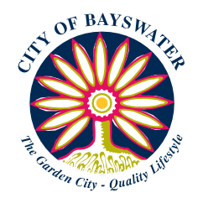

Harmony Week 2023 Your Origin Story

Name:
Age:
Email address:
Home country:

Tell us your origin story (please write 250-400 words in total)
Questions to help you get started:
- Tell us about the country and city/town where you and your family came from.
- Why did your family choose to come to Australia? How did you arrive?
- How did you and your family parents feel about moving to Australia?
- What do you know or remember about your home country?
- What were your first impressions of Australia?
- What do you like about living in Australia and Perth, Western Australia?
- Do you have a favourite place to visit or thing to do in the City with your friends/family?
Please note: All stories must be truthful and your own.
I have submitted images for consideration:

Yes No
I give consent for my child’s story/photographs to potentially be included in the Harmony Week 2023 e-book.
Parent name: ____________________
Signature: __________________
Date: __________________
DEADLINE FOR SUBMISSIONS – 24 February 2023

