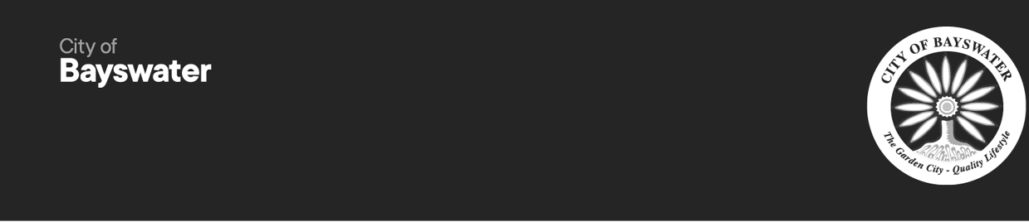
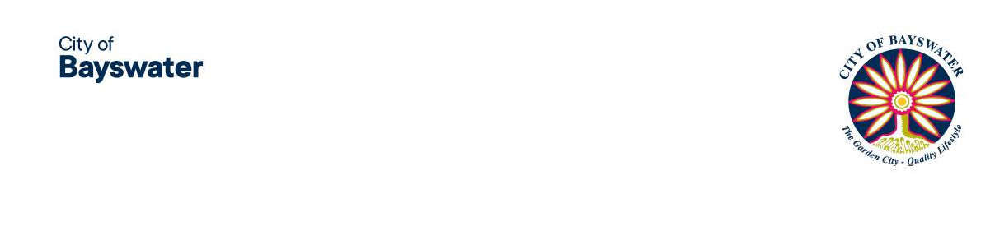

Inclusive Bayswater Advisory Group

Expression of Interest Nomination Form

Overview
The City of Bayswater is seeking expressions of interest for up to eight (8) community members to join the Inclusive Bayswater Advisory Group. The purpose of the Inclusive Bayswater Advisory Group is to support initiatives that promote equality and equal opportunity for people with a disability, people from culturally and linguistically diverse backgrounds, people who identify as LGBTQIA+, youth and older people. We are seeking a up to eight (8) community members who satisfy one or more of the following criteria:

- Live with a disability or are a parent, carer, advocate of a person with a disability, or be able to contribute expertise or advice on disability.
- Identify as LGBTQIA+; or be able to contribute expertise or advice on matters relating to LGBTQIA+.
- Identify as being from a culturally and linguistically diverse background or be able to contribute expertise or advice on matters relating to culturally and linguistically diverse backgrounds.
- Brings valuable lived experience as either a young person (aged 15–25) or an older community member (aged 55 and over), offering insights into the opportunities and challenges that these age groups face in accessing services, facilities and community life.
Community representatives are sought for a maximum of a two-year term, from the date of appointment until October 2027.

How to nominate
If you would like to make a positive contribution to your community and be part of the decision making process, please refer to the Terms of Reference, complete and submit the Nomination Form.

Nominations close 4.00pm on Saturday 13 December 2025
- In Person: 61 Broun Avenue, Morley WA 6062
- Email: mail@bayswater.wa.gov.au
- Post: PO Box 467, Morley WA 6943

The Terms of Reference are listed on the City's website: bayswater.wa.gov.au/advisory-groups
All applicants will be notified of the outcome of their expression of interest nomination following final assessment in early February 2026.

This form is available in alternative formats upon request.
Should you have any queries, please contact please contact Helen Smith, Manager Community Services on 9272 0608.

Nomination Form

Your Details:

Organisation (if relevant) First Name
Last Name Home address Email address
Daytime phone number

Please indicate which best describes you (check one or more boxes, if applicable):

  - Live with a disability or are a parent, carer, advocate of a person with a disability, or be able to
contribute expertise or advice on disability
  - Identify as LGBTQIA+; or be able to contribute expertise or advice on matters relating to LGBTQIA+.
  - Identify as being from a culturally and linguistically diverse background or be able to contribute expertise or advice on matters relating to culturally and linguistically diverse backgrounds.
  - Brings valuable lived experience as either a young person (aged 15-25) or an older community member (aged 55 or over), offering insights into the opportunities and challenges that these age groups face in accessing services, facilities and community life.

- Tell us why you are interested in joining the group:
Comment:

- What do you believe you can contribute to support promoting equality and equal opportunity for people with a disability, people from culturally and linguistically diverse backgrounds, people who identify as LGBTQIA+, youth and older people.+ accessing and utilising the City’s services and programs?
Comment:

- Are you involved in any other local committees/groups or involved with City of Bayswater community groups?

  - Yes
  - No
If yes, please tell us the name of the committee/group and your role:

Have you previously been a member of any of the City's working groups, committees or advisory panels?

  - Yes
  - No
If yes, please tell us the name of the working group, committee or advisory panel:

Have you read and understood the Inclusive Bayswater Advisory Group Terms of Reference?

- Yes

  - No
If no, please explain:

For further information please contact:
Manager Community Development on 9272 0608

