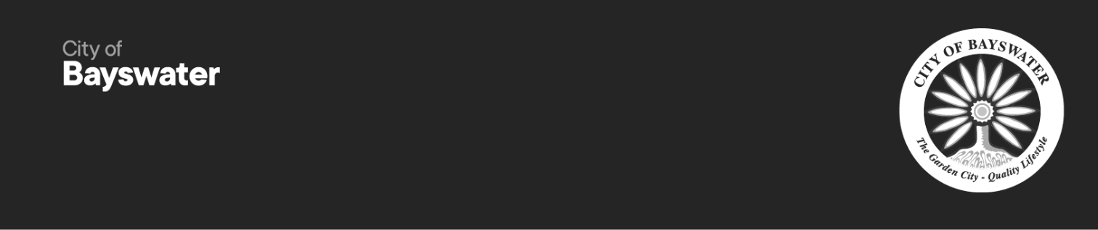
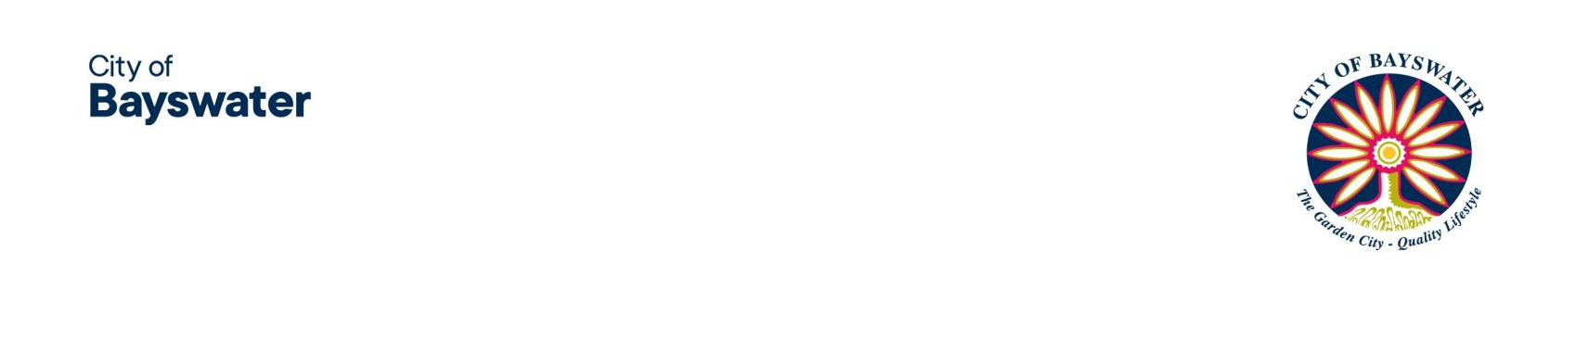

Reconciliation Advisory Panel Expression of Interest Nomination Form

Overview
The purpose of the Reconciliation Advisory Panel is to advise Council on the development and implementation
of the Reconciliation Action Plan (RAP) for the City of Bayswater, with the aim to help the workplace to facilitate understanding, strengthen relationships and trust with Aboriginal and Torres Strait Islander People; promote meaningful engagement, increase equality and develop sustainable employment and business opportunities.
We are seeking five community members who meet one or more of the following criteria:
- Identify as a person of Aboriginal and Torres Strait Islander descent;
- Is a Whadjuk Noongar Elder;
- Is an Aboriginal and Torres Strait Islander business partner representative; and/or
- Is an Aboriginal and Torres Strait Islander representative living in the City of Bayswater community.
Representatives are sought for a two-year term, until October 2027.

How to nominate
If you would like to make a positive contribution to your community and be part of the decision making process, please refer to the Terms of Reference, complete and submit the Nomination Form.

Nominations close 4.00pm on Saturday 13 December 2025.
- In Person: 61 Broun Avenue, Morley WA 6062
- Email: mail@bayswater.wa.gov.au
- Post: PO Box 467, Morley WA 6943
Nominations should be submitted in writing by completing the Expression of Interest (EOI) application on the City's website. The Terms of Reference and options for how to submit completed nominations are also listed on the City's website: bayswater.wa.gov.au/council-committees

All applicants will be notified of the outcome of their expression of interest nomination following final assessment by Council in early February 2026.

This form is available in alternative formats upon request. Should you have any queries, please contact please contact Helen Smith, Manager Community Development on 9272 0608.

Nomination Form Your Details:

Organisation (if relevant)
Pronouns
First Name
Last Name
Home address
Email address
Daytime phone number

Please indicate which best describes you (check one or more boxes, if applicable):
  - Identify as a person of Aboriginal and Torres Strait Islander descent;
  - Is a Whadjuk Noongar Elder;
  - Is an Aboriginal and Torres Strait Islander business partner representative; and/or
  - Is an Aboriginal and Torres Strait Islander representative living in the City of Bayswater community.

- Tell us why you are interested in joining the group:
Comment:

- What do you believe you can contribute to the group to help implement the City's Reconciliation Plan?
Comment:

- Are you involved in any other local groups/committees or involved with City of Bayswater community groups?
  - Yes
  - No
If yes, please tell us the name of the committee/group and your role:

Have you previously been a member of any of the City's working groups, committees or advisory panels?
  - Yes
  - No
If yes, please tell us the name/s of the working group, committee or advisory panel:

Have you read and understood the Reconciliation Advisory Panel Terms of Reference?
  - Yes
  - No
If no, please explain:

For further information please contact:
Manager Community Development on 9272 0608

